XXIX International scientific and practical conference "Modern scientific trends and youth development"
technical sciences
DETERMINATION OF THE PROBLEMS OF THE PROCESS OF LIQUIDATION OF EMERGENCY SITUATIONS IN THE CONDITIONS OF UNCERTAINTY OF THE SYSTEM OF TRAINING SPECIALISTS IN THE OPERATION OF EMERGENCY AND RESCUE EQUIPMENT

Pavlo Korchagin,
graduate student,
National University of Civil Defense of Ukraine
Ihor Khmyrov,
Doctor of Public Administration, Associate Professor,
National University of Civil Defense of Ukraine
Roman Shevchenko,
Doctor of Technical Sciences, Professor,
National University of Civil Defense of Ukraine
Shevchenko605@i.ua

During the hostilities, the system of training specialists of the State Emergency Service faced a number of challenges that significantly affected the quality of knowledge and skills that graduates of higher education institutions receive [1]. If the problem of the issue is considered only in the part of the training of specialists in the operation of emergency and rescue equipment, then the following should be noted. A stable structural and logical scheme of the process of coordination and improvement of the efficiency of the system of training specialists in the operation of emergency and rescue equipment requires the presence of a mandatory procedure for the coordination of operational and technical parameters of emergency and rescue equipment and the methodology of training specialists in its operation (Fig. 1).
The latter has a number of direct and reverse relations, which are aimed at improving the quality of the capabilities of the emergency prevention and response system, primarily at the regional level, and provides a planned basis for the application of both procedures for saturating the prevention system with new and modernized models of equipment, as well as a planned procedure for training specialists, which is constantly revised taking into account time and thematic limitations. Under today's conditions, the above coordination procedure is excluded from the process of distribution of emergency and rescue equipment, which comes in the form of humanitarian aid from partner countries. Humanitarian demining equipment and special dual-purpose equipment also remain outside its scope.
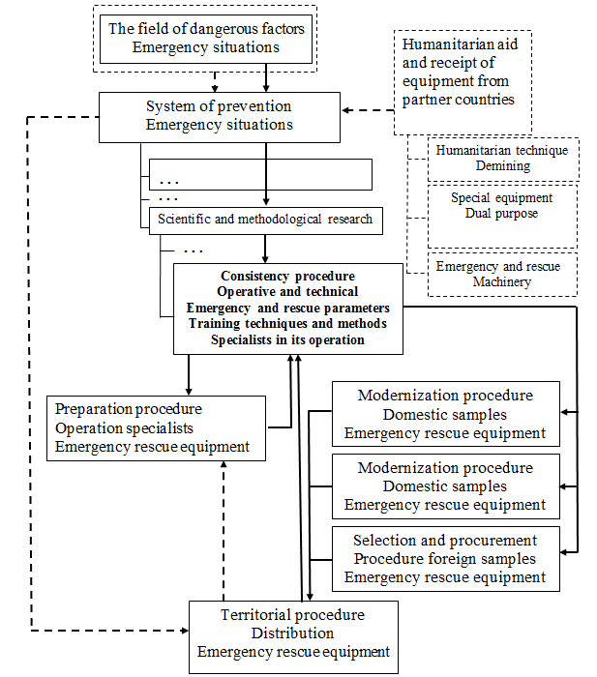

Fig. 1. Structural and logical scheme of the process of coordination and improvement of the efficiency of the system of training specialists in the operation of emergency and rescue equipment in everyday conditions and wartime conditions.

Violation of the feedback loop of the coordination procedure leads to the emergence of a number of contradictions that concern both the possibilities of comprehensive operation of the equipment and the training of relevant specialists in its operation, which in turn creates the problem of creating an effective methodology for increasing the effectiveness of the process of preventing emergency situations in conditions of uncertainty of the parameters of training specialists and operation of emergency rescue equipment, which are associated with organizational and management restrictions of wartime [1].
Analyzing the current state of the issue under investigation, one should, first of all, consider the world experience in the formation of methodologies for evaluating the effectiveness of the use of various fire-technical equipment. Thus, in separate works, the main criteria for a vague assessment of fire safety in the conditions of regions with a predominantly urban population are considered. Separate provisions of the theory of reliability of systems are also considered, using the example of the stability of logistical connections with the provision of fire equipment. Separate studies are devoted to solving the issue of integrated fire safety design, including elements of the GO methodology and the basics of reliability design.
Another direction is research on the training of specialists of emergency and rescue services of different levels of subordination. Thus, in separate works, the issue of increasing the effectiveness of training specialists in disaster medicine is considered. There is a direction devoted to the application of virtual simulation technology for the training of rescuers in the elimination of the consequences of an earthquake. A number of works are devoted to general issues of the use of modern technologies for the training of specialists in the operation of equipment for various purposes.
However, the comprehensive issue of the coherence of the systems of providing technical means and the appropriate training of specialists in their operation has not been resolved to date. It acquires additional relevance under the conditions of violation of feedback loops of the coordination procedure, which are associated with organizational and management restrictions of wartime.
Thus, based on the above, the purpose of the first stage of the research is to determine the issues and basic assumptions for the further formation of the methodology to increase the effectiveness of the emergency prevention process in conditions of uncertainty of the parameters of the training of specialists and the operation of emergency rescue equipment.
In order to achieve the set goal, the following tasks must be solved: consider the issues of the process of coordinating the processes of equipping emergency and rescue equipment and training relevant specialists; to form a structural and logical scheme of the methodology for increasing the effectiveness of the process of preventing emergency situations in the conditions of uncertainty of the parameters of the training of specialists and the operation of emergency and rescue equipment.

References:

1. Divizinyuk, M.M., Yeremenko, S.O., Lyevtyerov, O.O., Prusʹkyy, O.V., Striletsʹ, V.V., Striletsʹ, V.M., Shevchenko, R.I. (2022). Teoretychni zasidky paradyhmy «Tsyvilʹnyy zakhyst»: monohrafiya. Pid zah. redaktsiyeyu M.M. Divizinyuka ta R.I. Shevchenka. Kyyiv: TOV "AZIMUT-PRINT", 335 s.

